1. Install Power BI Desktop and share the final screenshot of the report view page which appears when power desktop starts.

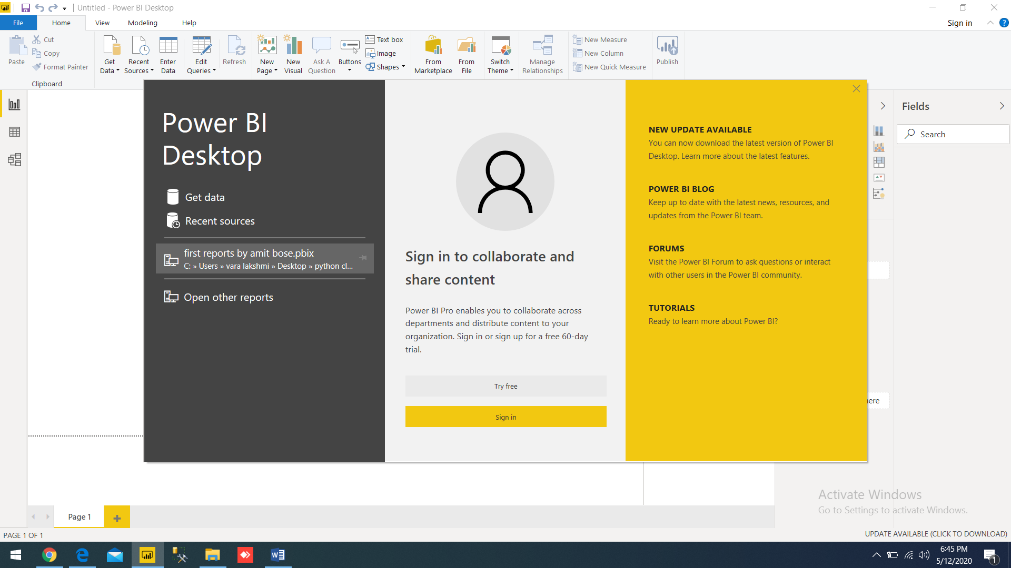

**POWERBI CANVAS PAGE SHOWN BELOW SCREENSHOT**

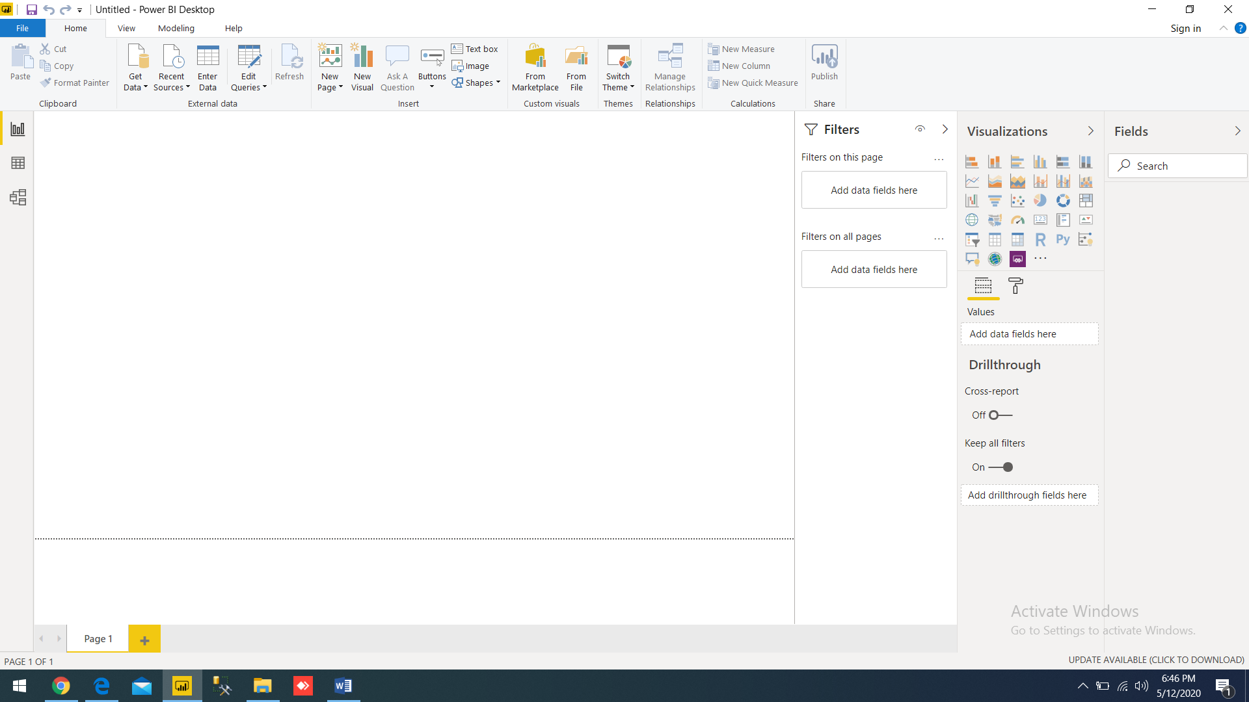

2) Prepare a document and with the following screenshot − Report View − Data View − Model View − Power Query Editor − Advance Editor

I want to show based on excel data connection:

When you click on the GET DATA from data connection, and select excel file below navigator will pop up

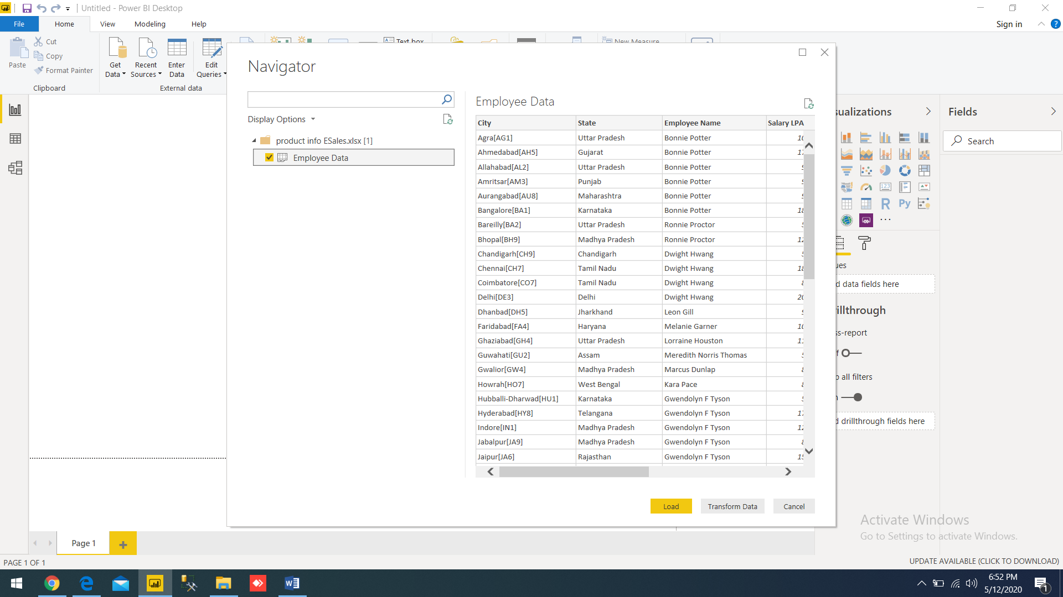

POWER QUERY:

Select table click on transform data to go to POWERQUERY EDITOR

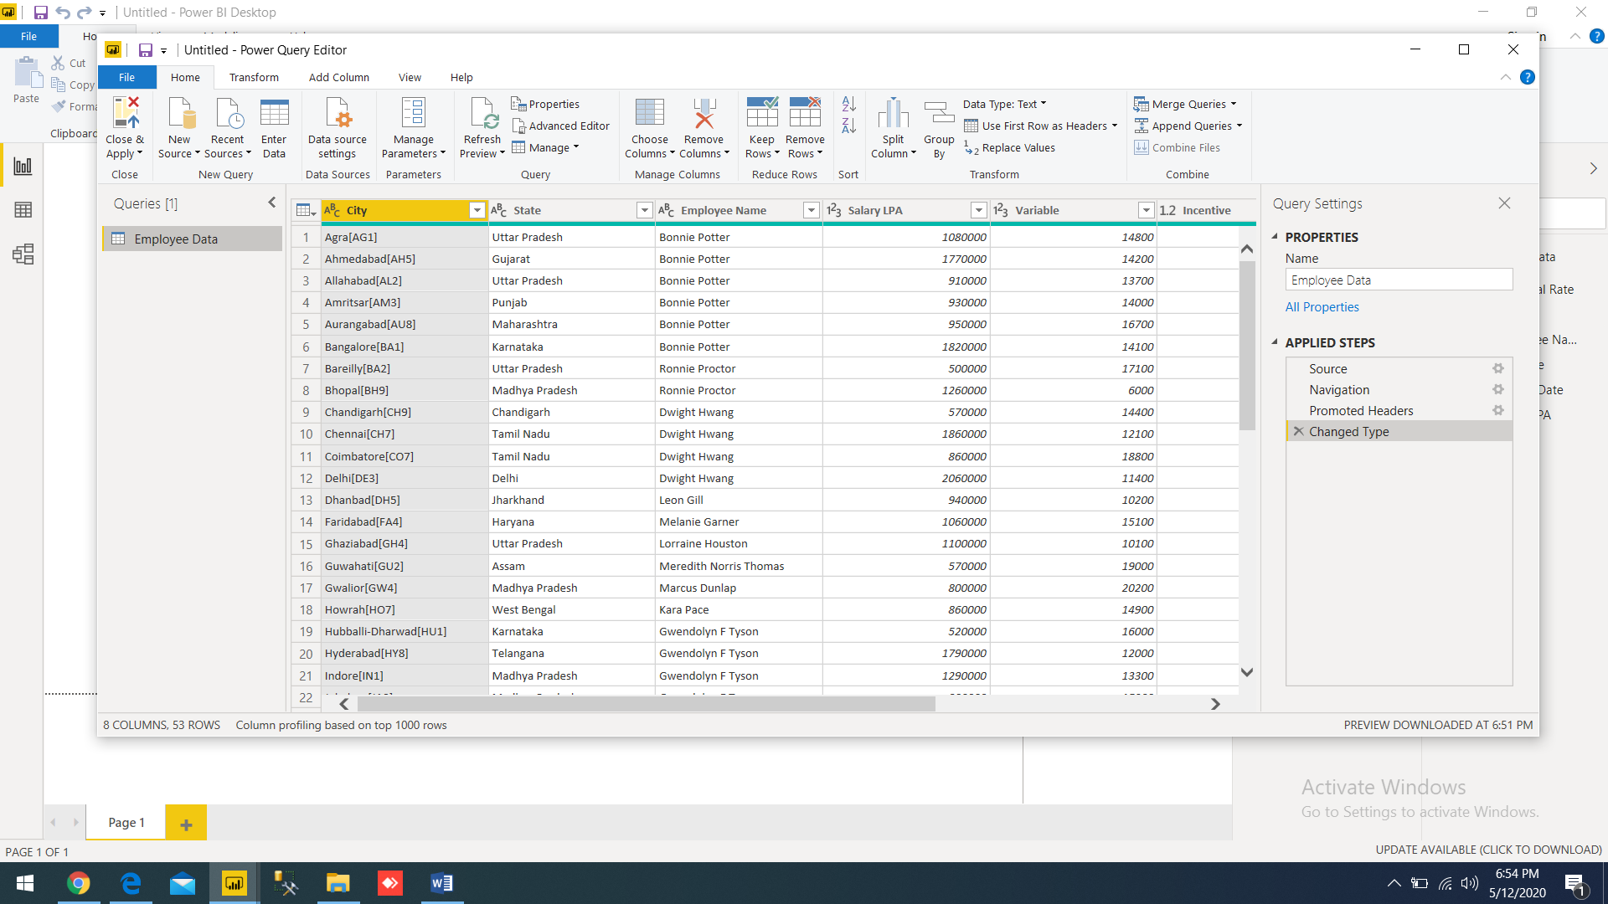

DO transformation and calculation to the data, NOW click on close & apply, data tables will be loaded to our powerbi desktop model (which show in fields pane)

DATA VIEW SCREENSHOT:

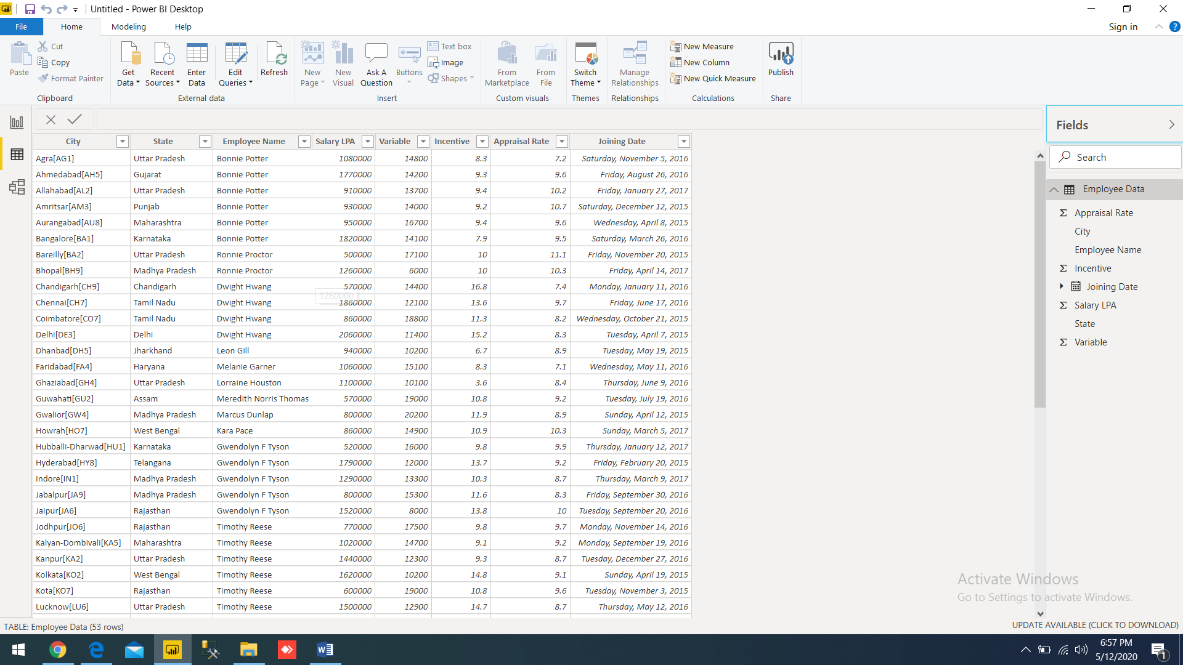

MODEL VIEW SHOW LIKE THIS:

You can build relationship between tables in this pane ( I load only one table)

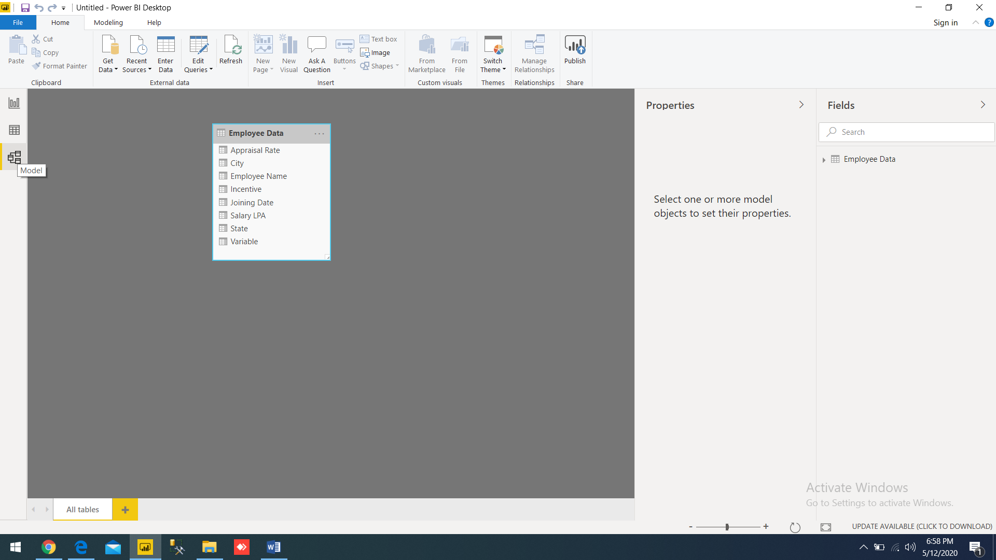

REPORT VIEW:

FINALLY in the power bi desktop, we can build reports in the report view based on tables data.

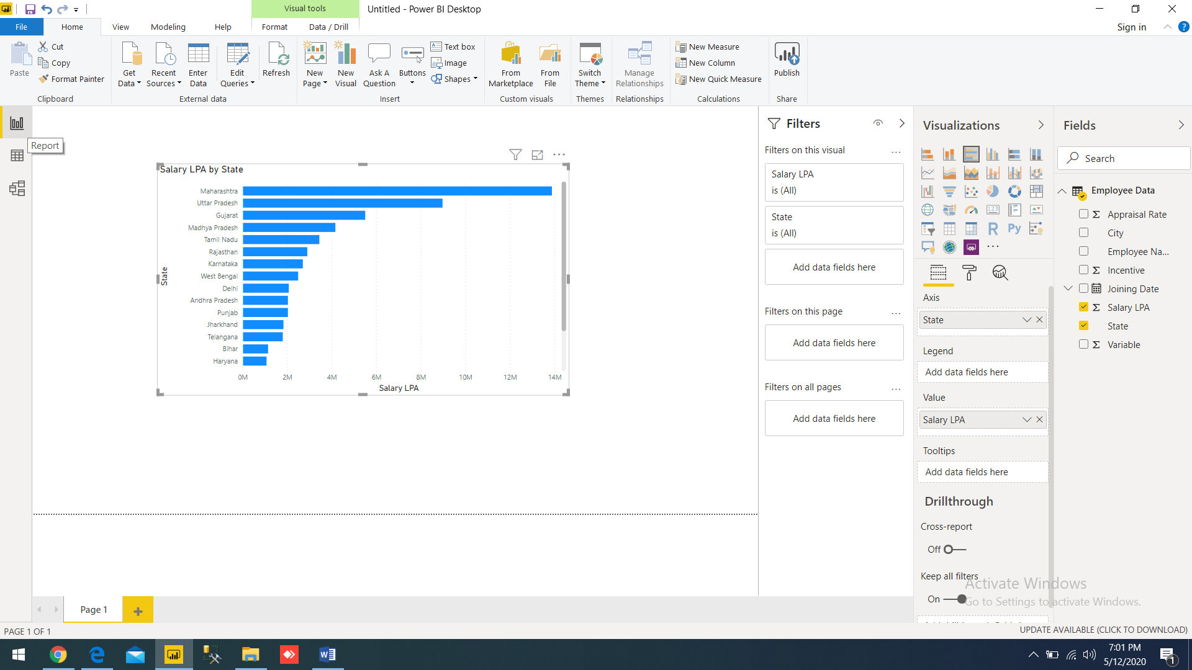

3) Prepare a document with details of the following along with their price

− Power BI Desktop − Power BI Pro − Power BI Premium

|  |  |  |
| --- | --- | --- |
| Powerbi bi desktop | Power BI Pro | Power BI Premium |
| It is desktop application which is free to use | For sharing dashboard we need power bi service. Pro version is free for the limited time(2 months), after this period you continue the services by paying $ 9.99 per month | It is advanced to pro version  Advanced controls will be given with this plan  Approximately the price is $4,995 per month  (capacity pricing) |
| No workspace | Upto 10 gb per user  (individual license) | Microsoft offers three capacities for premium  (enterprise license) |
| Dashboard sharing not allowed for free version | Dashboard sharing allowed | Dashboard sharing allowed |